This is an article written by Graham Paflin on the Buccaneer aircraft that stands on the gate at RAF Honington. This originally appeared in the “Rymer Court News” - Issue 4, Autumn 2014:

Buccaneer XK526
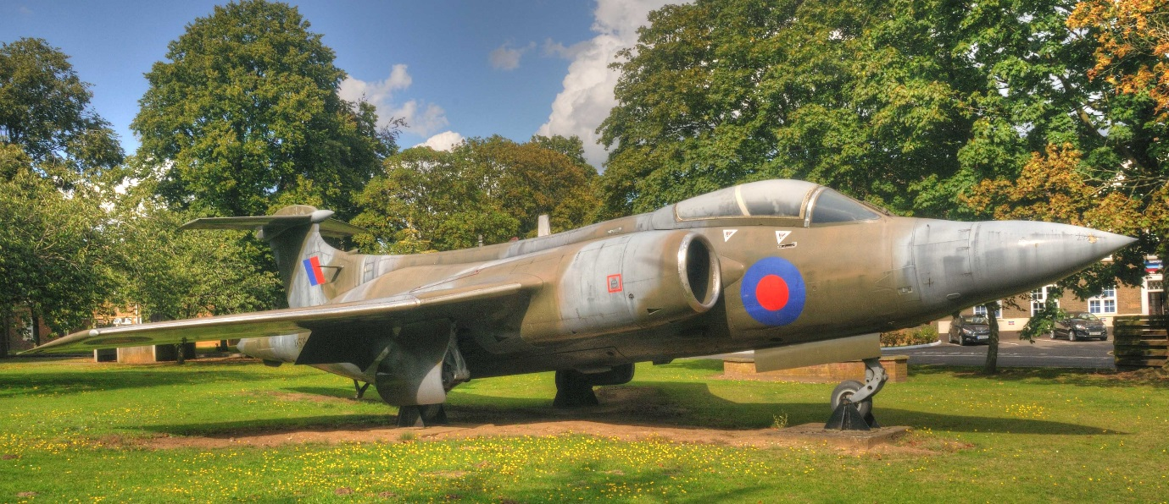
‘This is your Life!’
I expect that most people reading this will have noticed the aircraft sitting, rather forlornly, by the main gate at RAF Honington. It is quite common for old, retired military aircraft to be seen as ‘Gate Guardians’ at such establishments but a chance comment by Warrant Officer Bob Hargreaves, (our base contact when using their facilities for Residents Association meetings), led me to probe a bit deeper! In fact, I learned that XK526 had NEVER served on any Squadron! Perhaps I should start at the beginning……
In the early 1950’s, in the midst of the ‘Cold War’, the Royal Navy needed a strike aircraft capable of flying at 600mph+ for 400 miles at very low level whilst carrying 2 tons of nuclear or conventional weapons – rather a tall order. These requirements meant that the aircraft would need to be twin-engined, with a two-man crew, plenty of internal fuel and weapons storage and would have to operate from the aircraft carriers then in service with the Royal Navy which imposed limits on size and weight of any proposed design – an even taller order! It is also worth mentioning that the turbulence and buffeting of low level flight imposes severe strain on the airframe and when this is coupled with the stresses of carrier landings and catapult launches the end result is a demand for such aircraft to be built like the proverbial tank!
After the usual Government delays, the contract was eventually awarded to Blackburn Aviation who were given just under three years to design, build and get the new aircraft into the air with a first flight in April 1958. They did it – just! On 30th April 1958 the first Buccaneer took to the air.
Whilst all this was going on with the prototype, an order for a further 20 test and development aircraft was placed in June 1955 and ‘our’ Buccaneer was the 10th of these. XK 526 made its first flight on 29th August 1960 – 55 years ago! It then embarked on 2 years of extensive trials and experimentation, both in England and overseas, going as far as Singapore for tropical tests.
In addition to these test aircraft, a further 40 were ordered for the Fleet Air Arm for use on board Royal Navy aircraft carriers with 801 Squadron being the first to operate the Buccaneer in service in March 1962 at RAF Lossiemouth in Scotland before transferring to HMS Victorious 4 months later.
These early Buccaneers were the ‘S1’ variant which, whilst good, needed some improvement, chief amongst which was more power! The original S1’s had De Havilland Gyron Junior engines and if one should fail during take-off or landing, the remaining one had barely enough power to keep the aircraft in the air. Consequently, an ‘S2’ version was to be developed, based on the same airframe, and ‘our’ Buccaneer, along with sister XK527, was returned to the factory in November 1962 for updating to the new specification.
With new Rolls Royce Spey engines and new electrical systems, amongst myriad other changes, (it was perhaps the forerunner of “Trigger’s Broom!”), XK526 commenced another round of test and development work, making its first flight in S2 format in May 1963. It continued to be used in trials and experiments for the next 9 years.
Meanwhile the S2 variants were ordered into series production and FAA service with a total of 84 being built by the factory – by now part of the Hawker Siddeley group – and the Buccaneers served with distinction all around the world and were much loved by their crews.
You may have noticed that, up to this point, I have made no mention of the Buccaneer being an RAF aircraft – because it wasn’t! However, that was about to change. In April 1965 the Labour government announced the scrapping of the TSR2 project, (remember that?), and instead proposed to purchase American F111 swing-wing bombers, (like those that were based at Lakenheath some years ago), – but this was also cancelled when the costs began rising to levels even above what the TSR2 would have been! The RAF were instead ‘offered’ American F4 Phantoms and the British Buccaneer – some years earlier, when it was suggested that the Buccaneer could be used by the RAF, it had been derided and turned down flat! However in 1968 it was ‘decided’ that the RAF would adopt the Buccaneer after all – so in October 1969 the first Buccaneers came to Honington with 12 Squadron. Ultimately the RAF had 43 new S2B models and 62 ex FAA S2’s which gradually became surplus to requirements following the planned reduction in aircraft carriers as part of the Defence cuts with the last leaving the FAA for RAF duty in 1978
XK526, meanwhile, was still engaged in research and development work and in 1972 was flown to Marshalls at Cambridge to commence work on avionics and ‘sideways-looking’ radar for the Panavia MRCA project which eventually became the Tornado. In 1977 it was flown to Bedford, its work on the new radar completed, chiefly because this radar proposal was scrapped! XK526 was put into storage and never flew again. On 10th March 1980, XK526 made its final journey, by road, to RAF Honington to be used as an instructional airframe to assist in battle damage repair training. In 1983, with Honington becoming the base for the Operational Conversion Unit for the new Tornado, ‘our’ Buccaneer was moved to the base entrance as a ‘gate guardian’ – but that is not quite the end of the story, as we shall see!
Over the years, Buccaneers had served around the world in various roles but they only went to war once – during Operation Granby, probably better known as the first Gulf War in 1990-91. Initially they were used in carrying laser designation pods to ‘illuminate’ targets for Tornados which were flying alongside and assisted in the destruction of 20 bridges thereby impeding the movement of Iraqi troops. They also carried out their own bombing missions, targeting bunkers, runways, parked aircraft and conducting dive-bombing runs on any ‘targets-of-opportunity’. In total, they flew 218 missions – designating targets for other aircraft and dropping 48 laser-guided bombs themselves.
With an increasing number of Tornados entering service the end was in sight for the Buccaneer and so it was that on 31st March 1994 the Buccaneer fleet was finally retired.
But what of XK526? Gate guardians can be at the mercy of Whitehall ‘pen-pushers’ but memorials are not. Therefore in 1994 the status of XK526 was changed to become a memorial to all those who flew from Honington between 15/6/1937 and 31/4/1994, of whatever Nationality, and did not return.
Is this the end of the story? Warplanes are not built to last indefinitely and XK526 is already 54 years old and corrosion is becoming a major problem. There are no funds for restoration or even for some anti-corrosion treatment so eventually it will crumble to dust. The rumour is that it may be replaced by a plastic replica – what an ignominious end to a worthy veteran!

(Since this article was originally written, I have since learnt that XK526 is to be repainted in an attempt to preserve it for a while longer – although I haven’t seen any action yet!)

